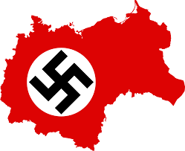
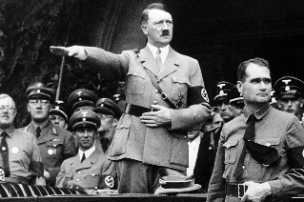

Year 11 Revision Booklet

Unit 2: Nazism in Germany
Name:______________________________
Week | Graphic organiser/method of revision/reading topic | Teacher check
1
2
3
4
5
6
7
8
9
10
11
12
13
14
15
16

Brainstorm

321RIQ
3 things you remember:

2 things you found interesting:

1 question you have:

PMI Chart
Complete the PMI chart outlining what was positive, minus (negative) and interesting about the topic.
Positive | Minus | Interesting

Summarise the Main Points

Venn diagram

Main Ideas | Details
Summary
Cornell Note Taking Method

Significant individual

